Reman Hussein Aboud Alhayali
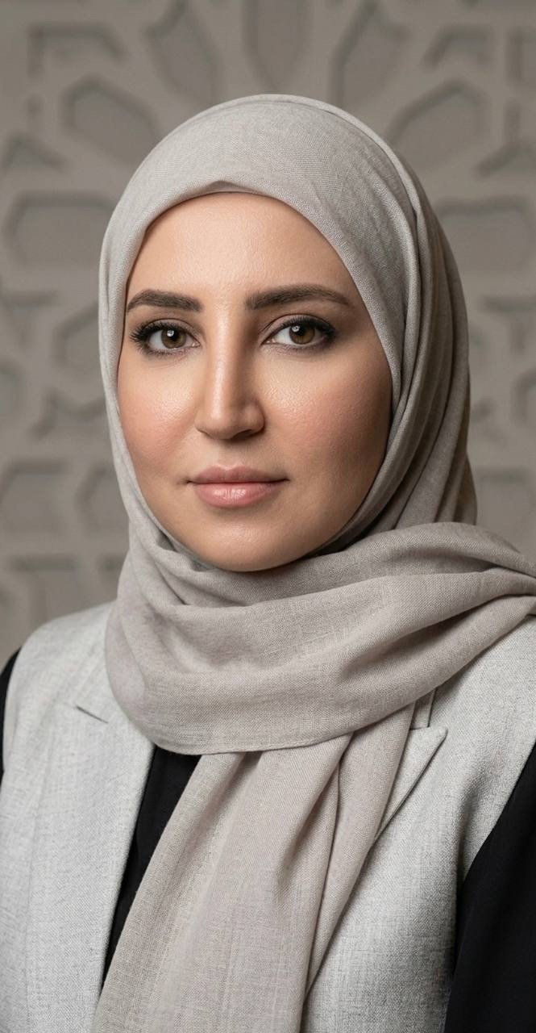
Assistant Lecturer

Contact Information
Phone: +9647705858615
Email: reman.h.a@uodiyala.edu.iq

Academic Affiliation
College of Veterinary Medicine - University of Diyala
Department of Histology, Anatomy and Embryology

Education
PhD Student (2026) - University of Baghdad
Master's Degree (2022) - University of Baghdad
Bachelor's Degree (2012) - University of Baghdad

Experience
Teaching Assistant - College of Medicine, University of Diyala
2012 - 2015
Teaching Assistant at the College of Medicine, Department of Anatomy and Histology

