®®
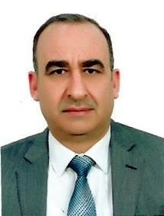

PROFILE
CURRICULUM VITAE

Amer Khazaal Saleh

EDUCATION
Bachelor: 1984 , Baghdad, Iraq
Master: 1999, Baghdad, Iraq
Ph.D.: 2011,UPM, Malaysia

PROFESSOR IN FACULTY OF VET. MED.
DIYALA UNIVERSITY
Born: 1961
Status: Married

EXPERIENCE
CONTACT

- Virus Isolation
- Serological &Molecular Technique
- Cell Culture
07711327232



amer.k@uodiyala.edu.iq
This Photo by Unknown Author is licensed under CC BY-NC-ND






REASERCH INTEREST

Virology
Molecular Biology
HOBBIES
This Photo by Unknown Author is licensed under CC BY-NC-ND

Reading
Writing
Visiting museum



