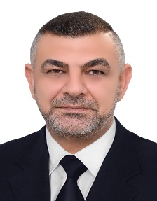 ®®

**PROFILE**

**CURRICULUM VITAE**

**Sabah Mahmood Hamad Al-Shammari**

**EDUCATION**

Bachelor: 2003, Baghdad, IRAQ

Master: 2018, Baghdad, Iraq

LECTURER IN FACULTY OF VET. MED.

DIYALA UNIVERSITY

Born: 1980

Status: Married

Diagnosis of fish diseases

Fish diseases treatments

General vet. medicine

**EXPERIENCE**

**CONTACT**

07705924882



dr.sabahmahmoud@uodiyala.edu.iq



[This Photo](https://askleo.com/how_do_i_change_my_email_address/) by Unknown Author is licensed under [CC BY-NC-ND](https://creativecommons.org/licenses/by-nc-nd/3.0/)

 <https://scholar.google.com/citations?user=whhqxtYAAAAJ&hl=ar>

<https://www.researchgate.net/profile/Sabah-Hamad-Al-Shammari>

**REASERCH INTEREST**





Reproduction in fish

Fish classification

Fish treatments

**HOBBIES**

[This Photo](https://askleo.com/how_do_i_change_my_email_address/) by Unknown Author is licensed under [CC BY-NC-ND](https://creativecommons.org/licenses/by-nc-nd/3.0/)





 